|  |  |  |
| --- | --- | --- |
|  | CSC ESA  GROUND SEGMENT OPERATIONS FRAMEWORK  OPERATIONS COORDINATION DESK SERVICE  [OMCS] SentiBoard Architecture and Interfaces Document |  |

|  |  |  |  |
| --- | --- | --- | --- |
| **Title:** | **CSC Coordination Desk – [OMCS] SentiBoard Architecture and Interfaces Document** | | |
| **Abstract**: | This document describes the architectural elements and the interfaces of the SentiBoard (formerly Public Dashboard) | | |
| **Author:** | CD Dev Team | **Verified:** | Andrea Bolle |
|  | **CSC Coordination Desk Dev Team** |  | **CSC Coordination Desk Service Manager** |
| **Approved**: | Andrea Bolle | **Authorised:** | Roberto Zaccari |
|  | **CSC Coordination Desk Service Manager** |  | **Product Assurance Manager** |
| **Accepted by ESA:** |  |  |  |
|  | | |  |
| **Filename:** | **CSC Coordination Desk - [OMCS] SentiBoard Architecture and Interfaces Document.docx** | | |

**Document Status Sheet**

|  |  |  |  |  |  |
| --- | --- | --- | --- | --- | --- |
| **ISSUE** | **DATE** | **AUTHOR** | **VERIFIED** | **APPROVED** | **REASON OF THE MODIFICATION** |
| 1.0 | 25/07/2024 | CD Dev Team | A. Bolle | A. Bolle | First Issue |

**Document Change Record History**

|  |  |  |  |  |
| --- | --- | --- | --- | --- |
| **No** | **Change In Issue** | **Description of Change** | **Section** | **Change made by** |
|  |  |  |  |  |

**Table of Content**

1 Introduction 6

1.1 Purpose 6

1.2 Structure of the document 6

2 Applicable and Reference Documents, Acronyms 7

2.1 Applicable Documents 7

2.2 Reference Documents 7

2.3 Acronyms and Abbreviations 7

3 SentiBoard architecture 9

3.1 Overview 9

3.2 The Flask Engine 10

3.3 SentiBoard backend 11

3.4 SentiBoard frontend 12

3.5 SentiBoard middle layer 15

4 SentiBoard Interfaces 16

4.1 Internal Interfaces 16

4.2 External Interfaces 18

4.2.1 Overview 18

4.2.2 External Interfaces for end users 18

4.2.3 External Interfaces for Elastic data retrieval 18

4.2.4 External Interface for TLE retrieval 19

**Index of Figures**

Figure 3‑1 SentiBoard Home page 9

Figure 3‑2 SentiBoard architecture overview 10

Figure 3‑3 The About page 12

Figure 3‑4 The Acquisition Status page 12

Figure 3‑5 The Events page 13

Figure 3‑6 The Datatakes page 14

Figure 3‑7 The Datatakes details panel, showing the completeness per product type 14

Figure 3‑8 The Publication Statistics page 15

Figure 4‑1 SentiBoard interfaces with external entities 18

**Index of Tables**

**Table 1 Applicable Documents** 7

**Table 2 Reference Documents** 7

**Table 3 Acronyms and abbreviations** 8

Table 4 SentiBoard Internal Interfaces 17

Table 5 SentiBoard External Interfaces for end users 18

Table 6 SentiBoard External Interfaces for data retrieval 19

# Introduction

The present document is delivered in the context of the OMCS branch of the CSC Coordination Desk Programme.

## Purpose

The purpose of the present document is to describe the main architectural element of the SentiBoard, formerly called “Public Dashboard”, along with the internal and external interfaces.

## Structure of the document

The present document is structured as follows:

* Chapter 1: Introduction – this Chapter;
* Chapter 2: Applicable and Reference documents, Acronyms
* Chapter 3: SentiBoard Architecture
  + 3.1 Overview
  + 3.2 The Flask Engine
  + 3.3 SentiBoard backend
  + 3.4 SentiBoard frontend
  + 3.6 SentiBoard middle layer
* Chapter 4: SentiBoard Interfaces
  + 4.1 Internal Interfaces
  + 4.2 External Interfaces

# Applicable and Reference Documents, Acronyms

## Applicable Documents

The following table lists the applicable documents.

| **Refer.** | **Title** | **Code** |
| --- | --- | --- |
| [AD-IL] | Invitation To Tender for ESA Ground Segment Operations Framework Operations Coordination Desk Service | AO/1-10177/12/I-BG-SC 13.05.2021 |
| [AD-SOW] | Copernicus Space Component - ESA Ground Segment Operations Framework – Coordination Desk Service - STATEMENT OF WORK | ESA-EOPG-EOPGC-SOW-20 Issue 1.0 |
| [AD-DC] | Appendix 2 to ITT – Draft Contract | 13.05.2021 |
| [AD-STC] | Appendix 3 to ITT – Special Conditions of Tender | 13.05.2021 |
| [AD-ADG] | Auxiliary Data Gathering Technical Requirements | ESA-EOPG-EOPGC-RS-17 Issue 1.0 |
| [AD-WEB] | Web Pages Operations Technical Requirement | ESA-EOPG-EOPGC-RS-14 Issue 1.0 |
| [AD-OMCS] | Operations Monitoring and Coordination Service Technical Requirements | ESA-EOPGEOPGC-RS-18 Issue 1.0 |
| [AD-SLA] | SLA and Key Performance Indicators | EOPG-EOPGC-TN-43 Issue 1.0 |
| [AD-SEC] | Coordination Desk Service - Security Requirements Document | ESA-EOPG-EOPGCS-SP-13 Issue 1.0 |
| [AD-CDP] | CSC PDGS/CDS Coordination Desk Procedures | COPE-GSEG-EOPG-PR-14-0035 Issue 2.0 |
| [AD-MNT] | CSC Ground Segment Coordinated Maintenance Procedure, | COPE-PMAN-EOPG-PR-14-0001 Issue 4.0 |
| [AD-CM] | CSC Ground Segment Configuration Management Requirements, | ESA-EOPG-CSCOP-RS-14 Issue 1.0 |
| [AD-AMP] | CSC Ground Segment Anomaly Management Procedure, | GMES-GSEG-EOPG-PR-13-0008 Issue 4.0 |
| [AD-CIDL] | CSC Coordination Desk – Configuration Data Item List | ESA-EOPG-EOPGC-TN-45 Issue 1.0 |

**Table 1 Applicable Documents**

## Reference Documents

The following table lists the reference documents.

| **Refer.** | **Title** | **Code** |
| --- | --- | --- |
| [RD-ARCH] | CSC Operations – ESA Framework – Ground Segment Architecture, | ESA-EOPG-EOPGC-TN-7 Issue 1.2 |
| [RD-MICD] | Copernicus Space Component ESA Ground Segment Operations Framework-MasterICD | ESA-EOPG-EOPGC-IF-6 Issue 1.2 |
| [RD-CSDAR] | Copernicus Sentinel Data Access Report https://scihub.copernicus.eu/twiki/pub/SciHubWebPortal/AnnualReport2019/COPESERCO-  RP-20-0570_-_Sentinel_Data_Access_Annual_Report_Y2019_v1.0.pdf |  |
| [RD-EUG] | EU green public procurement criteria for data centres, server rooms and cloud services | SWD(2020) 55 final |
| [RD-NRJ] | Acton, M., Bertoldi, P., Booth, J., Flucker, S., Newcombe, L., Royer, A. and Tozer, R., 2019 Best Practice Guidelines for the EU Code of Conduct on Data Centre Energy Efficiency, European Commission, Ispra, 2018, | JRC114148 |
| [RD-GL] | CSC Sentinel Ground Segment Operations Glossary | ESA-EOPG-EOPGC-TN-13 |
| [RD-STB] | System Technical Budget | ESA-EOPG-EOPGC-TN-09 Issue 1.4 |

**Table 2 Reference Documents**

## Acronyms and Abbreviations

The following table contains all acronyms and abbreviations used in the current document.

| Acronym/Abbreviation | Definition |
| --- | --- |
| API | Application Programming Interface |
| AUX | Auxiliary |
| AUXIP | Auxiliary Interface (delivery) Point |
| CADU | Channel Access Data Unit |
| Cal/Val | Calibration/Validation |
| CCD | Copernicus Coordination Desk |
| CFI | Customer Furnished Item |
| COM | European Commission |
| CSC | Copernicus Space Component |
| CVIP | Calibration & Validation Interface (delivery) Point |
| DD | Data Distribution |
| DP | Documentation Package |
| DPA | Dynamic Procurement Approach |
| E2E | End-to-End |
| EC | European Commission |
| ECMWF | European Centre for Medium-Range Weather Forecasts |
| EDRS | European Data Relay Satellite System |
| EO | Earth Observation |
| EOF | ESA Operations Framework |
| EOP | Earth Observation Programme |
| ESA | European Space Agency |
| EU | European Union |
| EUM | EUMETSAT |
| FC | Frame Contract |
| FTP | File Transfer Protocol |
| GS | Ground Segment |
| HKTM | Housekeeping Telemetry |
| ICD | Interface Control Document |
| IF | Interface |
| IP | Interface (delivery) Point |
| IPF | Instrument Processing Facility |
| ITT | Invitation To Tender |
| KPI | Key Performance Indicators |
| LTA | Long Term Archive |
| MP | Mission Planning |
| MPIP | Mission Planning Interface (delivery) Point |
| ODP | On-Demand Processing |
| ODPRIP | On-Demand Processing Interface (delivery) Point |

**Table 3 Acronyms and abbreviations**

# SentiBoard architecture

## Overview

[SentiBoard](https://operations.dashboard.copernicus.eu/index) (formerly called “Public Dashboard) is a web application promoted by the European Space Agency in the framework of the Coordination Desk Programme.

This web application is meant to provide users with real-time, aggregated data about the status of the acquisition of the areas of their interest, the presence of issues potentially having an impact on data production, the planning of the future acquisitions and the details on the status of every data product.

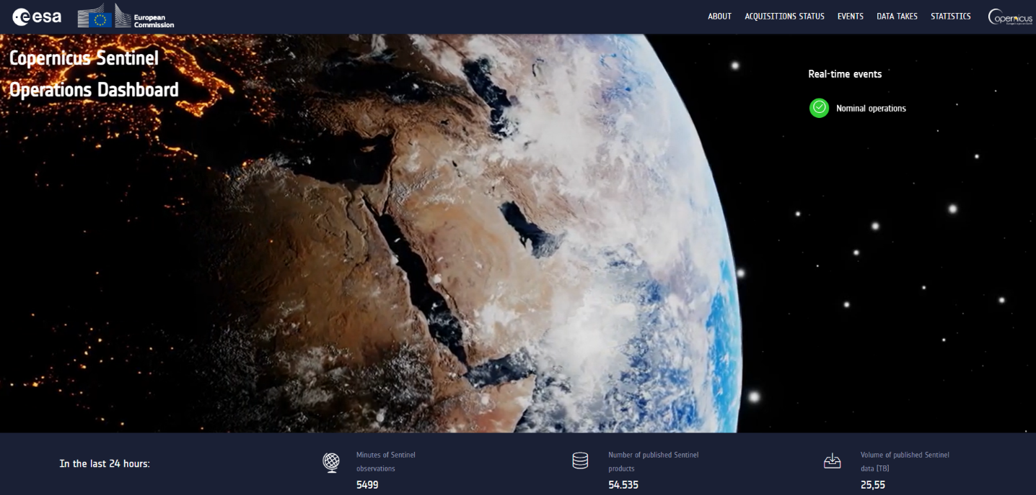

Figure 3‑1 SentiBoard Home page

More in details, SentiBoard offers the following views:

* An [About](https://operations.dashboard.copernicus.eu/about.html) page, with the general information on the web application
* An [Acquisition Status](https://operations.dashboard.copernicus.eu/acquisitions-status.html) page, with an interactive, 3D globe permitting to see in both real and simulated time the position of the Sentinel satellites and the past, current and future acquisitions
* The [Events](https://operations.dashboard.copernicus.eu/events.html) page, showing the issues with a tangible effect on data takes (acquisitions), together with a synthetic view of the impact on production. In case of major events, the details of the issue report also the link to the relevant news on Sentinel Online
* The [Data Takes](https://operations.dashboard.copernicus.eu/data-takes.html) page, collecting the status of the data take acquisition up to 3 months in the past. It reports also the future acquisitions foreseen in the next two days
* The [Publication Statistics](https://operations.dashboard.copernicus.eu/publication-statistics.html) page, providing a summary of the number / size of Sentinels products, grouped by timeliness type and product types, published in the last 24h, 7 days, 30 days or 3 months

The main source of information for data aggregation is the Technical Dashboard, developed in the framework of the Coordination Desk programme.

SentiBoard is deployed as a docker application, with 2 containers, hosting:

1. The main web application, consisting of:
   1. A frontend, managing the web pages visualization
   2. A backend, with the business logic
2. The Redis cache, permitting to save the temporary data on a flash memory unit. Data remain available for 24h by default, but the duration of the cache can be extended.

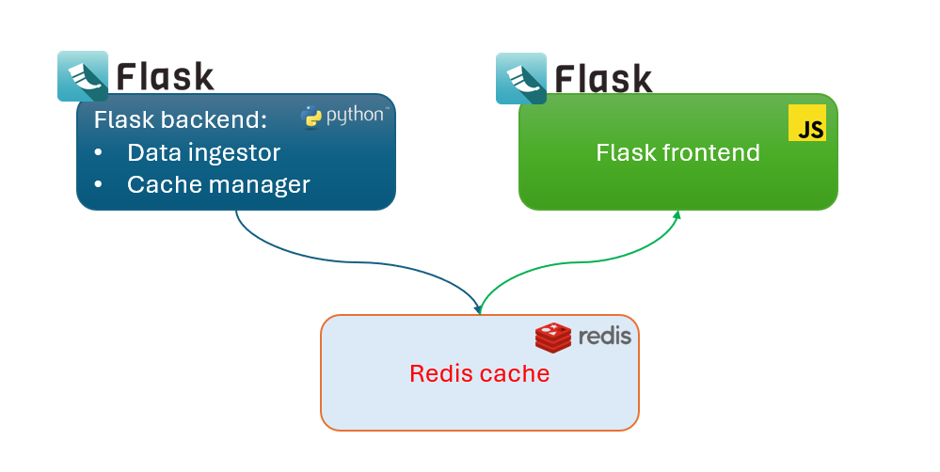

Figure 3‑2 SentiBoard architecture overview

The Redis cache has been introduced as the conjunction point between the raw data ingestion and aggregation, and the frontend, deserving an immediate response.

The workflow is the following:

1. At startup, or/and every hour, an ingestion job is thrown, aiming to collect data through queries addressed to the Elastic Database of the Technical Dashboard
2. Ingested and aggregated data are stored in the Redis cache
3. Queries from the frontend are addressed to the Redis cache: in this way, the response time is only given by the data circulation from the Redis cache, and not by the ingestion and processing phases.

## The Flask Engine

[**Flask**](https://flask.palletsprojects.com/en/3.0.x/)is a micro [web framework](https://en.wikipedia.org/wiki/Web_framework) written in [Python](https://en.wikipedia.org/wiki/Python_(programming_language)). It is classified as a [microframework](https://en.wikipedia.org/wiki/Microframework) because it does not require additional tools or libraries. It has no [database](https://en.wikipedia.org/wiki/Database) abstraction layer, form validation, or any other components where pre-existing third-party libraries provide common functions. However, Flask supports extensions that can add application features as if they were implemented in Flask itself. Extensions exist for object-relational mappers, form validation, upload handling, various open authentication technologies and several common framework related tools.

Applications that use the Flask framework include [Pinterest](https://en.wikipedia.org/wiki/Pinterest) and [LinkedIn](https://en.wikipedia.org/wiki/LinkedIn).

Flask has many configuration values, with sensible defaults, and a few conventions when getting started. By convention, templates and static files are stored in subdirectories within the application’s Python source tree, with the names’ templates and static respectively. While this can be changed, you usually don’t have to, especially when getting started.

The microframework Flask is part of the Pallets Projects (formerly Pocoo), and based on several others of them, all under a BSD license:

* **Werkzeug** (German for "tool") is a utility library for the Python programming language for Web Server Gateway Interface (WSGI) applications. Werkzeug can instantiate objects for request, response, and utility functions. It can be used as the basis for a custom software framework and supports Python 2.7 and 3.5 and later.[15][16]
* **Jinja**, also by Ronacher, is a template engine for the Python programming language. Similar to the Django web framework, it handles templates in a sandbox.
* **MarkupSafe** is a string handling library for the Python programming language. The eponymous MarkupSafe type extends the Python string type and marks its contents as "safe"; combining MarkupSafe with regular strings automatically escapes the unmarked strings, while avoiding double escaping of already marked strings.
* **ItsDangerous** is a safe data serialization library for the Python programming language. It is used to store the session of a Flask application in a cookie without allowing users to tamper with the session contents.

Flask is based on two main concepts, namely “**views**” and “**Blueprints**”. Below, a description of these concepts is reported.

A **view** function is the code you write to respond to requests to your application. Flask uses patterns to match the incoming request URL to the view that should handle it. The view returns data that Flask turns into an outgoing response. Flask can also go the other direction and generate a URL to a view based on its name and arguments.

A [**Blueprint**](https://flask.palletsprojects.com/en/2.1.x/api/#flask.Blueprint) is a way to organize a group of related views and other code. Rather than registering views and other code directly with an application, they are registered with a blueprint. Then the blueprint is registered with the application when it is available in the factory function.

An application with resources protected by authentication will have at least two blueprints, one for authentication functions and one for the core-business functions. The code for each blueprint will go in a separate module. Since the blog needs to know about authentication, you’ll write the authentication one first.

## SentiBoard backend

The backend is represented by the Flask light-weight server, written in Python (v3.10 is used for the present tool). It consists of two main modules:

* The **elastic data ingestor**, retrieving the raw data from the Technical Dashboard database
* The **cache manager**, aggregating the data and saving them into the Redis cache.

Both modules, represented by python code packages, contain dedicated files meant to manage specific data types. The ingestor module is entitled to collect the data, while the cache manager is meant to aggregate and cache them:

* *Acquisitions Plans*: these files are ingested from [Sentinel Online](https://sentinel.esa.int/web/sentinel), by accessing the following pages:
  + [Sentinel-1 Acquisition Plans](https://sentinel.esa.int/web/sentinel/copernicus/sentinel-1/acquisition-plans)
  + [Sentinel-2 Acquisition Plans](https://sentinel.esa.int/web/sentinel/copernicus/sentinel-2/acquisition-plans)
  + For Sentinel-3 and Sentinel-5P, data takes are reconstructed by the datatakes sensing time and the orbital datum
* *Datatakes*: these data are retrieved from the Technical Dashboard for all Sentinels missions
* *Events*: these data are retrieved from the Technical Dashboard for all Sentinels missions
* *Publication*: information on publication statistics is retrieved from the Technical Dashboard and aggregated, so to be presented in a global form

## SentiBoard frontend

SentiBoard frontend is represented by a number of HTML pages, compatible with version 5.0, managed by a set of corresponding Javascript files, importing the following main libraries:

* Jquery 13.1
* Bootstrap 4.0

Below, an overview of the web application pages is provided.

The [About](https://operations.dashboard.copernicus.eu/about.html) page reports a summary of all the available pages, together with the contact point in case of issues.

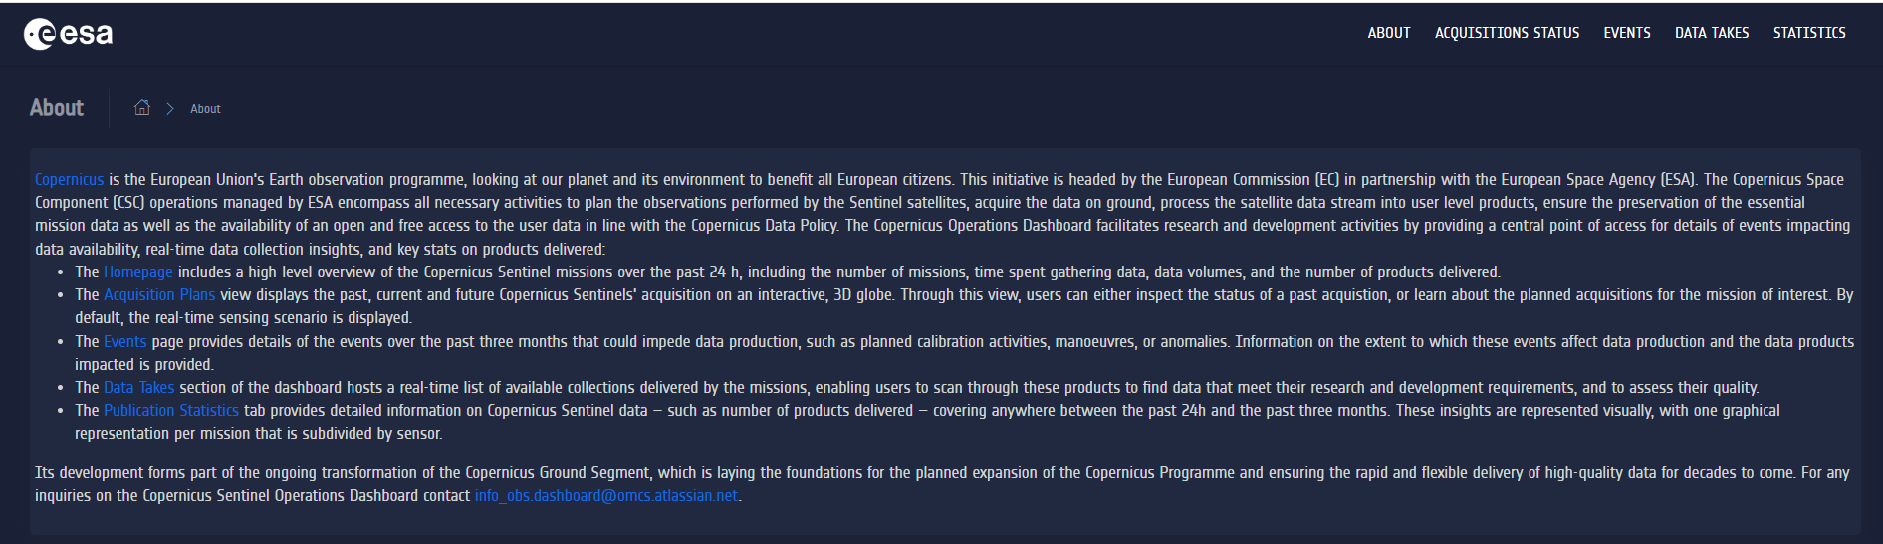

Figure 3‑3 The About page

The [Acquisition Status](https://operations.dashboard.copernicus.eu/acquisitions-status.html) page (formerly “Acquisition Plans”) offers an interactive, 3D globe permitting to see in both real and simulated time the position of the Sentinel satellites and the past, current and future acquisitions. By default, the view shows the real-time position of the Copernicus Sentinels satellite; however, by selecting a datatake from the top-right dropdown menu, the simulation time is shifted to the beginning of the selected acquisition. Datatakes can be filtered by selecting the satellite and the acquisition date. By clicking on the icon, it is possible to inspect the published products relevant to the selected datatake.

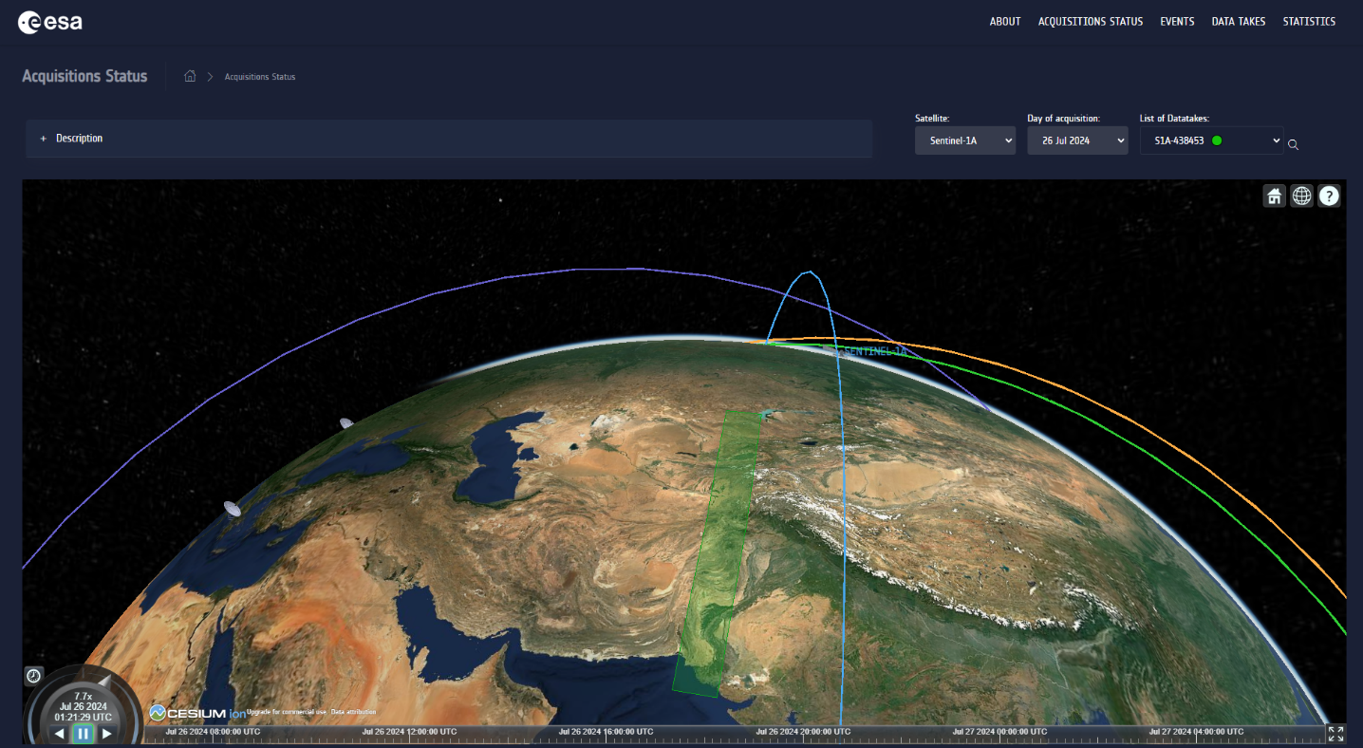

Figure 3‑4 The Acquisition Status page

The [Events](https://operations.dashboard.copernicus.eu/events.html) page is meant to show the issues with a tangible effect on data takes (acquisitions), together with a synthetic view of the impact on production. Events are categorized according to the following issue types:

* Satellite: issue due to instrument unavailability
* Calibration: issue occurred during sensor calibration
* Manoeuvre: issue occurred during the execution of a manoeuvre
* Acquisition: issue occurring during the reception of the data at the ground station
* Production: issue occurred during data processing

By clicking on each occurrence, the list of possibly impacted datatakes considering their sensing times is displayed in the right-side panel, together with further event details. The impact on datatake completeness is represented by the right-side coloured circle. The "green" colour indicates that the total completeness is spared; "orange" is used in case of medium impact; the "red" colour is used when the datatake is lost.

Events can be filtered by entering the satellite name (i.e. "Sentinel-1A"), or the category of interest, in the top-right search box.

In case of major events, the details of the issue report also the link to the relevant news on Sentinel Online.

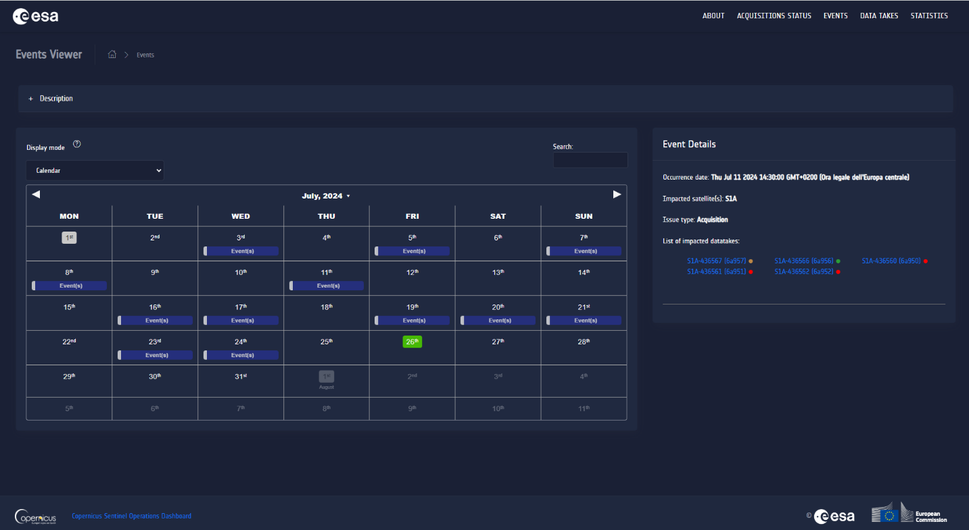

Figure 3‑5 The Events page

The [Data Takes](https://operations.dashboard.copernicus.eu/data-takes.html) page, collecting the status of the data take acquisition up to 3 months in the past. It reports also the future acquisitions foreseen in the next two days. Besides the acquisition platform and sensor mode, this table shows, for every datatake, the acquisition status and the total publication completeness, expressed in terms of percentage, with a hourly refresh rate. Records can be filtered using the search bar in the top-right side of the table, by entering the mission or satellite name (i.e. "S1" or "S2A"). Datakes can be also filtered on the basis of the sensing time, by selecting the time period of interest in the top-right part of the header bar. Datatakes can be also filtered using combined queries on different columns: as an example, try writing "S1 2024-01-22" to select all datatakes of the Copernicus Sentinel-1 mission, acquired in the specified date.

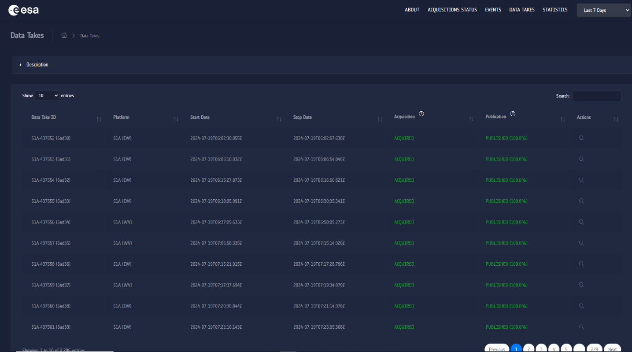

Figure 3‑6 The Datatakes page

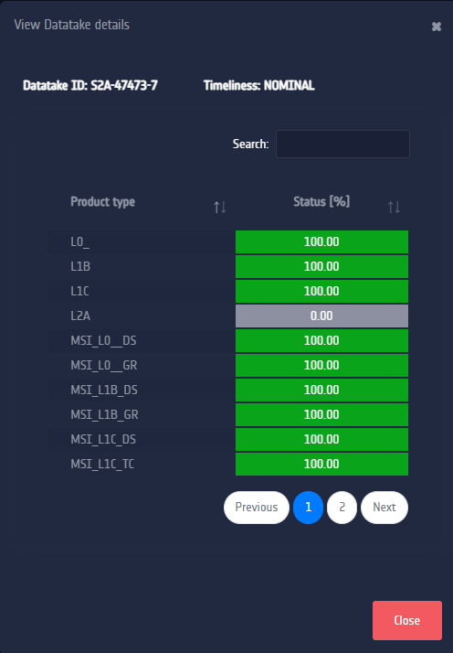

Figure 3‑7 The Datatakes details panel, showing the completeness per product type

The [Publication Statistics](https://operations.dashboard.copernicus.eu/publication-statistics.html) page offers a summary of the total number and volume of products published in the Data Hubs for each Copernicus Sentinel mission, within the selected time interval: last 24 hours, last 7 days, last 30 days and last 3 months (i.e. 90 days) with respect to the current date / time. The view provides also the details about the published products per product level or sensor type (i.e., for Copernicus Sentinel-3). Charts are interactive: by clicking on a label in the legend it is possible to modify the displayed results.providing a summary of the number / size of Sentinels products, grouped by timeliness type and product types, published in the last 24h, 7 days, 30 days or 3 months.

Figure 3‑8 The Publication Statistics page

## SentiBoard middle layer

The middle layer is represented by the REST APIs used by the frontend to invoke the data stored in the Redis cache. For details on these interfaces, please refer to 4.1.

# SentiBoard Interfaces

## Internal Interfaces

This section reports the internal interfaces of the SentiBoard, i.e. the description of the REST APIs used to retrieve the aggregated data from the Redis cache.

|  |  |  |
| --- | --- | --- |
| **API URL** | **Method** | **Description** |
| /api/acquisitions/acquisition-plans/<mission>/<satellite>/<day> | GET | Returns the datatakes for the specified mission[1], satellite[2] and day, in the form of a KML |
| /api/acquisitions/acquisition-plan-days | GET | Returns a dictionary of all datatakes in the default time window, divided by day |
| /api/acquisitions/satellite/orbits | GET | Returns the CZML corresponding to the Sentinels orbits in the default time window |
| /api/acquisitions/stations | GET | Returns the CZML with the location of the Acquisition Stations |
| /api/events/anomalies/update | GET | Allows the refreshing of the metadata of anomalies already cached |
| /api/events/anomalies/last-<period_id> | GET | Returns all the anomalies in the selected period[3] |
| /api/events/anomalies/previous-quarter | GET | Returns all the anomalies in the previous completed quarter |
| /api/events/anomalies/<date_from>/<date_to> | GET | Returns all the anomalies from 00:00:00 of <date_from> to 23:59:59 of <date_to>[4] |
| /api/worker/cds-datatakes/<datatake_id> | GET | Returns all products associated to the specified datatake |
| /api/worker/cds-datatakes/last-<period_id> | GET | Returns all datatakes in the specified time period |
| /api/worker/cds-datatakes/previous-quarter | GET | Returns all datatakes in the previous quarter |
| /api/statistics/cds-product-publication-volume/last-<period_id> | GET | Returns the volume of all published products, for all mission, grouped by product type, in the specified time period |
| /api/statistics/cds-product-publication-volume/previous-quarter | GET | Returns the volume of all published products, for all mission, grouped by product type, in the previous completed quarter |
| /api/statistics/cds-product-publication-count/last-<period_id> | GET | Returns the number of all published products, for all mission, grouped by product type, in the specified time period |
| /api/statistics/cds-product-publication-count/previous-quarter | GET | Returns the volume of all published products, for all mission, grouped by product type, in the previous completed quarter |

Table 4 SentiBoard Internal Interfaces

## External Interfaces

### Overview

SentiBoard External Interfaces belong to three distinct families:

* The URLs of the web pages exposed to the end users
* The Elastic queries to the Technical Dashboard database, which are firewall protected and not accessible from external entities
* The REST API query to download the orbital files (TLE) from [Celestrak](https://celestrak.org/) website.

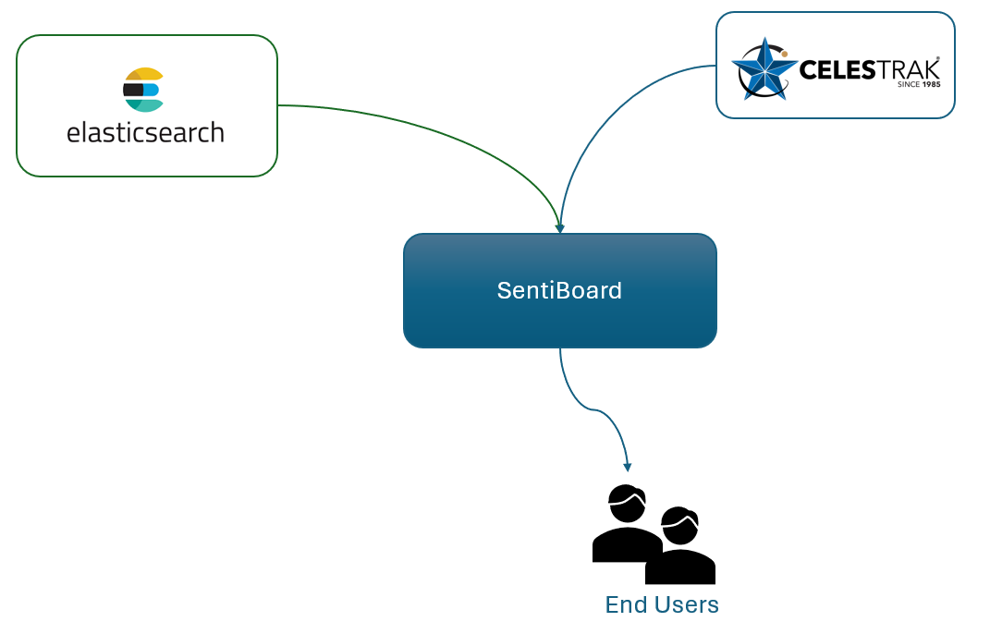

Figure 4‑1 SentiBoard interfaces with external entities

Below, a dedicated description for the three groups of interfaces is provided.

### External Interfaces for end users

This section reports the URLs exposed to the end users for web pages navigation.

|  |  |
| --- | --- |
| **Web Page** | **URL** |
| Home | https://operations.dashboard.copernicus.eu/index |
| About | https://operations.dashboard.copernicus.eu/about.html |
| Acquisition Plans | https://operations.dashboard.copernicus.eu/acquisitions-status.html |
| Events | https://operations.dashboard.copernicus.eu/events.html |
| Data Takes | https://operations.dashboard.copernicus.eu/data-takes.html |
| Publication Statistics | https://operations.dashboard.copernicus.eu/publication-statistics.html |

Table 5 SentiBoard External Interfaces for end users

### External Interfaces for Elastic data retrieval

This section describes the SentiBoard external interfaces used for data retrieval.

Data are stored into an Elastic Search database, whose endpoints are exposed by the Technical Dashboard. [Elasticsearch](https://www.elastic.co/elasticsearch) is a distributed, RESTful search and analytics engine, based on the [Lucene](https://en.wikipedia.org/wiki/Lucene) library, scalable data store, and vector database capable of addressing a growing number of use cases. As the heart of the Elastic Stack, it centrally stores data for lightning fast search, fine‑tuned relevancy, and powerful analytics that scale with ease. Characteristic examples of queries can be found at this [link](https://coralogix.com/blog/42-elasticsearch-query-examples-hands-on-tutorial/).

For the purpose of the SentiBoard data representation, the following indexes are used.

|  |  |
| --- | --- |
| **Index** | **Description** |
| cds-datatakes | Used to retrieve information about datatakes of Sentinel-1 and Sentinel-2 |
| cds-products | Used to retrieve all products associated to datatakes, together with information about completeness and publication timeliness. This interface is used to aggregate the information of datatakes of Sentinel-3 and Sentinel-5P |
| cds-cams-tickets | Used to retrieve all anomalies with impact on datatakes completeness |

Table 6 SentiBoard External Interfaces for data retrieval

### External Interface for TLE retrieval

To retrieve orbital data, SentiBoard connects to Celetrak and download the text file associated to the specified satellite units. Below, details about this interface are reported:

* Celestrak endpoint:

[https://celestrak.org/NORAD/elements/gp.php?CATNR={sat_id}](https://celestrak.org/NORAD/elements/gp.php?CATNR=%7bsat_id%7d), where {sat_id} is the identifier of the satellite

* Method: GET
* Please refer to [this link](https://en.wikipedia.org/wiki/Two-line_element_set) for details on the TLE format

1. Allowed values for <mission> field are: “S1”, “S2”, “S3”, “S5P”
2. Allowed values for <satellite> field are: “S1A”, “S2A”, “S2B”, “S3A”, “S3B”, “S5P”
3. Allowed values for <period> field are: “24h” (24 hours), “7d” (7 days), “30d” (30 days) and “quarter” (last 90 days, including today)
4. ISO format 8601 for “date_from” and “date_to” is “YYYY-MM-dd”